Deployment of App in IBM Cloud

**Upload the Image to IBM Container**

|  |  |
| --- | --- |
| Team ID | PNT2022TMID50454 |
| Project Name | Nutrition Assistant Application |

Creating Repository in IBM Cloud

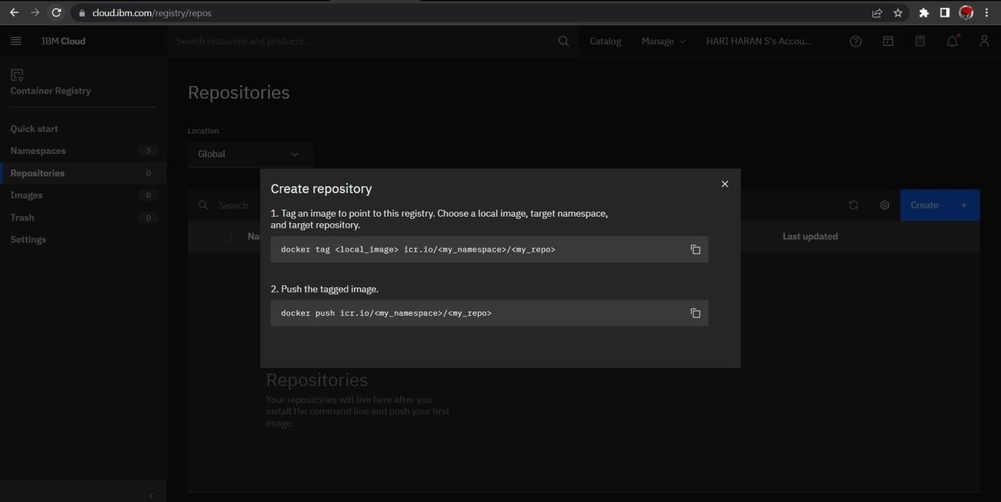

Upload Inage to IBM Cloud Registry

